EBU6304 Software Engineering Group Project

2025-26
Group number | 70
member 1 | QM no: 231225915 | Name: Li Guanlin
member 2 | QM no: 231225834 | Name: Hong Haoran
member 3 | QM no: | Name:
member 4 | QM no: | Name:
member 5 | QM no: | Name:
member 6 | QM no: | Name:

Final short report

Design
Explain the design strategy and provide detailed design descriptions at different levels, such as architecture, components, and the design principles and patterns applied. You may use diagrams where appropriate to illustrate and support your design ideas.

1.1 Design Strategy
This design strictly follows the software engineering principles and agile architecture design methods. We adopt an agile incremental design strategy and prioritize requirements using the “MoSCoW method” (Must Have / Should Have / Could Have / Want Have), which provide directions for the progress of the work at each stage. This project is implemented in Java, stores data in text files (CSV format), and strictly adheres to the principles of “no databases, no reliance on heavy-duty frameworks”. All design decisions were based on the Proposal submitted by our team during the initial phase of the project, which included background research, stakeholder interviews, and document analysis. Subsequent design and development continue to build upon the low-fidelity prototype.

1.2 System Architecture
This project adopts the “4+1 Architecture View Model” for system design, providing a comprehensive description of the system architecture from five different perspectives:
- Logical View: Core objects are categorized based on the **Entity-Boundary-Control (EBC) model**:
- Entity classes: `User` (user), `Position` (position), `Application` (application), `Topic/Comment` (forum topic/comment), `TaNotification` (notification) – objects that store persistent data
- Boundary classes: `AuthUI` (login interface), `TAJobsUI` (job listing interface), `MoPublishUI` (posting interface), `MoReviewUI` (review interface), `AdminUI` (administrator interface), `ProfileUI` (profile interface) – User interface components
- Control classes: `AuthService` (Authentication Manager), `TAJobService` (Application Manager), `MOReviewService` (Review Controller), `AdminService` (Administrator Service), `MoPublishUService` (Publication Controller), etc. – These are business logic controllers.

- Development View: When developing the project, we divided it into seven functional modules:
- `admin_system/` — Administrator system module (includes model, repository, and foundation sub-packages)
- `auth/` — Authentication and session management module
- `profile/` — User profile and CV management module
- `ta_jobs/` — Module for browsing and applying for TA positions
- `mo_publish/` — MO Position Publishing Module
- `mo_review/` — MO Review and Interview Management Module
- `forum/` — Forum discussion module
Within each module, there’s also a modular package structure (ui/dao/service/util). The dependency flow is: UI → Service → Repository → CSV Storage. Dependencies are unidirectional, and cross-layer calls are not allowed.
- Process View: Considering that this is a lightweight campus application with a limited number of users and no need for high-concurrency handling, we’ve adopted a single-threaded GUI approach with synchronous business processes to meet the requirements of a lightweight course management system.
  - Main Thread: Java Swing Event Dispatch Thread (EDT), responsible for handling all UI interactions
  - Business threads: Service layer methods are executed synchronously in EDT, with no concurrent or asynchronous tasks.
  - File I/O: Synchronous file reading and writing is performed using `CsvUtil` and `FileStorageUtil`. File locks are utilized to prevent concurrent writing conflicts.
- Physical View: Standalone applications developed using Java Swing, with local file storage:
  - Deployment unit: A single Java application (`Home2.java` serves as the entry point)
  - Data storage: CSV files in the local `data/` directory (`users.csv`, `positions.csv`, `applications.csv`, etc.)
  - Running environment: JRE 8+. No server, database, or external middleware required.
  - Portability: For user convenience, the RunApp.bat file has been created, allowing users to simply click to compile and run the application.
- Scenario View: Architecture validation driven by core user processes:
  - Scenario 1 (TA applies for a position): Log in (`AuthUI`) → Browse positions (`TAJobsUI`) → Apply for a position (`TAJobService`) → Check status (`TAJobsUI`) → Receive notifications (`TaNotificationService`)
  - Scenario 2 (MO publishing and review): Log in (`MoPublishUI`) → Publish a position (`MOPublishService`) → View applications (`MoReviewUI`) → Update status (`MOReviewService`) → Send notifications (`TaNotificationService`)
  - Scenario 3 (Administrator Approval): Log in (`AdminUI`) → View users awaiting approval (`AdminService`) → Approve/Reject (`UserRepository`) → Record audit logs (`FileStorageUtil`)

1.3 Layered Architecture & Components
The system adopts a “three-layer architecture” with a clear separation of concerns:
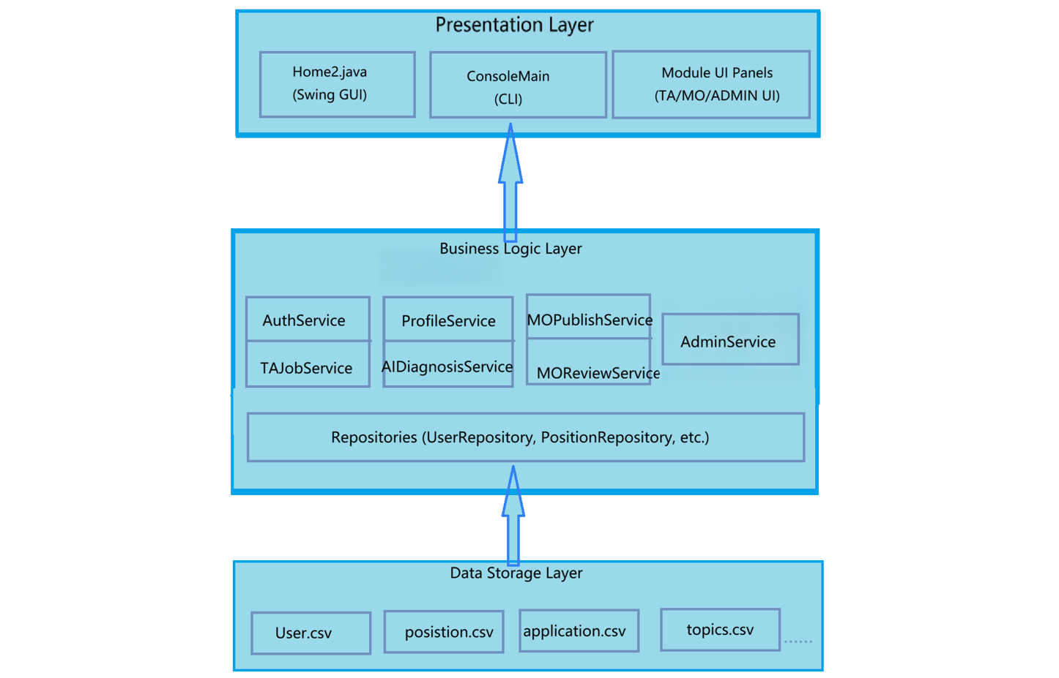
Presentation Layer: Handles user interaction through Swing GUI components (`Home2.java`, `AuthUI`, `TAJobsUI`, etc.) and CLI interface (`ConsoleMain.java`). This layer delegates all business operations to the service layer.

Business Logic Layer: Contains two sub-layers:
- **Service Layer**: Implements business rules and workflows (`AuthService`, `TAJobService`, `MOReviewService`, etc.)
- **Repository Layer**: Abstracts data access operations (`UserRepository`, `PositionRepository`, `ApplicationRepository`)

Data Storage Layer: Persistent storage using CSV files in the `data/` directory. Repositories handle all read/write operations through utility classes (`CsvUtil`, `FileStorageUtil`).
Architectural Style: Layered architecture with strict unidirectional dependencies. The presentation layer depends on services, services depend on repositories, and repositories handle CSV I/O. No layer skips another.

1.4 Design Principles & Patterns
Design Principles
- Single Responsibility Principle (SRP): Each class should have only one responsibility.
- Open-Closed Principle (OCP): Core business code does not need to be modified when adding new functionality. For example, dependency injection can be handled through RecruitmentSystemContext. Thus, adding new modules like Forum or AI Diagnosis does not require altering the existing core service code.
- Liskov Substitution Principle (LSP): This project does not use inheritance hierarchies. All roles (TA/MO/Admin) are distinguished by the User.role field. Role-specific behaviors are implemented through composition rather than inheritance.
- Interface Segregation Principle (ISP): This project uses direct dependencies between specific classes, with interfaces being used sparingly. Each module has clear responsibilities, avoiding the problem of “fat interfaces”.
- Dependency Inversion Principle (DIP): Dependency injection is performed using RecruitmentSystemContext as the composition root. The Service layer depends on the Repository class, thereby achieving inversion of control. The Repository encapsulates the details of CSV data access.
Design Patterns
1. MVC Pattern: Separates the user interface (view), business logic (controller), and data (model).
2. Utility patterns: Classes like CsvUtil, FileStorageUtil, and SecurityUtil use static methods. They don’t require instantiation and provide global utility functions.
3. Factory Pattern (partially used): IdGenerator provides a unified method for ID generation, while CsvUtil offers a general-purpose method for converting CSV rows into objects.
4. Appearance Pattern: RecruitmentSystemContext serves as the system’s composite root, bringing together all core services (AuthService, TAJobService, MOReviewService, etc.). It provides a unified access point for the entire system, simplifying dependency management between modules.
5. Observer Pattern: Notifications are sent when key business events occur, such as changes in application status or new user registrations. The notification logic is decoupled from the business logic. Services trigger notifications by calling TaNotificationService, rather than having the notification logic embedded in the business code.

Implementation
Outline the implementation strategy and project build plan. Discuss how version control is used to support development and collaboration.

Testing
Describe the testing strategy, techniques, test case design, and the test results. Give specific examples.

The use of Generative AI (GenAI)
Describe the GenAI tool(s) used at different stages of the software development process. Critically evaluate their effectiveness in supporting development activities and discuss their limitations and challenges.
To here - No more than 10 pages including tables, charts, figures and diagrams you may have.

Individual contribution and reflection
Each group member should provide one paragraph outlining their key contribution to the project (this must be agreed by the group) and another paragraph reflecting on their learning experience (this should include thoughts on the overall process, challenges encountered, and skills developed). Maximum 300 words for each member. Copy the template below.
QM no: 231225834
Name: Hong Haoran
Main contribution: I was primarily responsible for the TA-side job module (ta_jobs/) and the advanced TA-12 AI Diagnosis feature. My work covered TAJobService and TAJobsUI for browsing open positions, semester-aware filtering (CurrentSemesterStore and PositionSemesterStore), duplicate-application prevention, and integration with the Home2 search bar. I implemented TA-12 end-to-end: CV text extraction from uploaded PDF/DOCX files (CvTextExtractor), skill indexing from CV and profile data (ApplicantSkillIndex), keyword-based matching against open positions (AiDiagnosisService), and the recommendation UI (AiDiagnosisUI) with match scores and reasons. I also added PositionDetailUI so TAs can double-click a job row to open a full-page detail view and apply directly, wired through RecruitmentSystemContext and the TA homepage AI Diagnosis entry. I resolved portable CV path resolution (CvPathResolver) when uploaded files are stored locally, and delivered the work through branches Honghaoran_aidiagnose and Honghaoran_jobdiscribtion, which were merged into main.
Reflective statement: This project improved my ability to extend an existing layered Java/Swing codebase without breaking other modules. The biggest challenge was implementing TA-12 without external AI libraries or databases: CV parsing had to work with plain Java, and matching quality depended on uploaded CV content and profile skills. Debugging CV file missing errors taught me the difference between persisted paths in users.csv and actual files on disk, especially after Git pulls. Integrating new UI flows into Home2 also required careful reuse of TAJobService rather than duplicating business rules. Overall, I developed stronger skills in requirement-driven design, incremental delivery through Git branches and pull requests, and writing user-facing error messages that guide recovery. Working in a team repository further reinforced service/repository separation and keeping TA job logic inside ta_jobs/.

